|  |  |
| --- | --- |
|  | **Sri Lanka Institute of Information Technology** |



PROJECT REGISTRATION FORM

|  |
| --- |
|  |

(This form should be completed and uploaded to the Cloud space on or before XXXXXXXXX)

The purpose of this form is to allow final year students of the B.Sc. (Hon) degree program to enlist in the final year project group. Enlisting in a project entails specifying the project title and the details of four members in the group, the internal supervisor (compulsory), external supervisor (may be from the industry) and indicating a brief description of the project. The description of the project entered on this form will not be considered as the formal project proposal. It should however indicate the scope of the project and provide the main potential outcome.

|  |  |
| --- | --- |
| PROJECT TITLE  (As per the accepted topic assessment form) | E-Ketha : Enriching rice farmer’s quality of life through a mobile application |

|  |  |
| --- | --- |
| RESEARCH GROUP  **(as per the Topic assessment Form)** | Machine Learning and Soft Computing (MLSC) |

|  |  |  |
| --- | --- | --- |
| PROJECT NUMBER |  | (will be assigned by the lecture in charge) |

PROJECT GROUP MEMBER DETAILS: (Please start with group leader’s details)

|  |  |  |  |  |
| --- | --- | --- | --- | --- |
|  | **STUDENT NAME** | **STUDENT NO.** | **CONTACT NO.** | **EMAIL ADDRESS** |
| Format | Perera C.D.D | ITxxxxxxxx | 0712345678 | [itxxxxxxxx@my.sliit.lk](mailto:itxxxxxxxx@my.sliit.lk) |
| 1 | Salika Madhushanka W.J (GROUP LEADER) | IT19101620 | 0771373018 | [it19101620@my.sliit.lk](mailto:it19101620@my.sliit.lk) |
| 2 | P.Y.D Jayasinghe | IT19117256 | 0773762743 | [it19117256@my.sliit.lk](mailto:it19117256@my.sliit.lk) |
| 3 | H.H.W.M.Binuka Sihan Paranagama | IT19129372 | 0765537570 | [it19129372@my.sliit.lk](mailto:it19129372@my.sliit.lk) |
| 4 | K.M.Umesh Ranthilina | IT19240152 | 0770313651 | [it19240152@my.sliit.lk](mailto:it19240152@my.sliit.lk) |

**SUPERVISOR, CO_ SUPERVISOR Details**

|  |  |
| --- | --- |
| **SUPERVISOR Name** | **CO-SUPERVISOR Name** |
| **Mr. Adeepa Gunarathna** | **Ms. Amali Upeka Gunasinghe** |
| **Signature** | **Signature** |
| **Attach the email as Appendix 1** | **Attach the email as Appendix 2** |
| **12/01/22** | **12/01/22** |
| **Date** | **Date** |

|  |  |  |  |  |  |
| --- | --- | --- | --- | --- | --- |
| EXTERNAL SUPERVISOR Details (if any, may be from the industry) | | | | | |
|  |  |  |  | **Attach the email as Appendix 3** |
| Name | Affiliation | Contact Address | Contact Numbers | Signature/Date |

|  |  |  |
| --- | --- | --- |
| ACCEPTANCE BY CDAP MEMBER (This part will be filled by the RP team) | | |
|  |  |  |
| Name | Signature | Date |

PROJECT DETAILS

|  |
| --- |
| Brief Description of your Research Problem: (extract from the topic assessment form) |
| Several concerns were found that negatively affect the farmers and the rice crops that reduce the productivity along with profit.   * The first major issue when it comes to paddy is the prevalence of diseases that are native to rice. With new diseases and sicknesses being found each passing day, it becomes difficult for the common farmer to identify and treat them. What is closely related to diseases are pests and other unwanted insects that are also attracted to the crops. These pests might be the reason that diseases are created from the plant in the first place, as well as the reason why diseases are distributed. Pests, even while not spreading disease, might make the crops unsanitary for human consumption. * The second issue is the growth of unwanted weeds that are prevalent in paddy fields. While weeds do not directly harm rice crops, weeds absorb nutrients from the paddy fields that should have gone for the development of healthy rice plants. The identification of weeds however is not difficult for the common farmer, but the true challenge lies in the recognition of proper weedicide to combat the identified weed. This is due to vast amount of weed types and the equally wide variety of weedicides being difficult to recollect for the common famer. * The next issue is the recognition of suitable fertilizers that are needed for the crops to grow healthy and abundant. Farmers due to lack proper guidance tent to use incorrect fertilizers, fertilizers that have considerable side effects or even the correct fertilizers in wrong amounts thus making it harmful. This has become a major problem in Sri Lanka today due there being reports of various health concerns for the consumer such as increasing the risk of Alzheimer’s disease and Diabetes. The environment is also damaged as a repercussion, examples being contaminated waterways and the destruction of algae. * Finally, there have been concerns about the fact that, farmers are lacking in knowledge when it comes to the lifecycle of rice crops and whether the rice plant is in the proper phase of the lifecycle at the given time. This can cause mistreatment or no treatment altogether thus resulting poor harvest and there by profit. |
| Description of the Solution: (extract from the topic assessment form)  In order to overcome the research problems above mentioned, a mobile application was proposed that mainly uses image processing and machine learning.   * For the issue of diseases and pests, the application will be using its mobile host’s camera to take a picture of the afflicted rice crops. This picture could be either diseased rice crops, pests or the rice crops harmed by pests. Then this picture or pictures will be analyzed using advanced image processing to identify the prosecutor using the crop’s type, shape and color. After finding the root cause, advanced machine leaning algorithms will be used to give the most suitable solution to handle the diseased rice crops or to remove the type of pests. * For the second issue, farmer has the capability of uploading aerial pictures of the paddy fields to identify the hotspots of weed located in the said paddy fields. When in those hotspots, application will use the phone’s camera to capture images of the unwanted weeds and pinpoint the type they belong to. The image processing will consider the height, length, shape, color, etc.. for it to be taken in by the machine learning algorithm so as to discover the most fitting fix. This will enable the farmer to remove the weed without the affecting the rice crops. * For the third issue, the camera of the farmer’s cellular phone will be taking a photograph of the rice crops in the paddy field as well as the fertilizer. The image processing will then do its task of calculating the area of the paddy field and the identification of the fertilizer. When the area and type is known, the machine learning will be suggesting the fertilizer’s proper amount and other necessary information including the guidance and the ingredients, so as to not negatively impact the environment or living creatures. * For the final issue, the application will have the capability to measure the rice crop so as to identify the current lifecycle phase. This of cause will be done by the use of mobile camera and image processing technology. Before doing this farmer will have to input the type of the rice crop as well as the date it was planted. After the phase is discovered, if there is any deficiency, the application will be providing the information regarding the deficiency in addition to the proper treatment through machine learning. |

|  |
| --- |
| Main expected outcomes of the project: (extract from the topic assessment form) |
| The main objective of this research project is to help farmers with their paddy fields and make life easier for them. The farmers will be receiving proper guidance and techniques so that producing a steady abundant yield of crops to match the great demand of consumers. Farmers will have the opportunity of exchanging information among one-another so as to regulate knowledge.  **Sub Objective 1:** Detection of pests and diseases using image processing and finding solutions by applying machine learning.  **Sub Objective 2:** Detection of weeds using image processing and finding solutions by applying machine learning.  **Sub Objective 3:** Identification of fertilization information according to the size of paddy field and the fertilizer using image processing, then after providing the instructions by applying machine learning.  **Sub Objective 4:** Rice crop growth identification using image processing and giving solutions to debilitated crops by applying machine learning. |

WORKLOAD ALLOCATION (**extract from the topic assessment form after the correction suggested by the topic assessment panel.**)

(Please provide a brief description about the workload allocation)

|  |  |
| --- | --- |
| MEMBER 1 | ………………………………………Salika Madhushanka W.J: IT19101620  Detection of pests and diseases using image processing and finding solutions by applying machine learning. ……………………………………………………………………………………………………………………………………… |
| The first component of the application will be detection of pests and diseases using image processing and finding solutions by applying machine learning. This member is responsible for collecting data and information about various forms of diseases that can trouble rice crops in addition to equally numerous pests that can harm them as well. The data will take the form of images for the use of image processing functionality that will also be implemented by this particular member. After this is completed the application user will have the ability to take a picture of diseased or a pest-ridden crop to identify the type of disease or pest. Then after a machine learning algorithm will be enacted by the member, that will have the capability to present the most suitable solutions to treat the crops. | |

|  |  |
| --- | --- |
| MEMBER 2 | P.Y.D Jayasinghe: IT19117256  Detection of weeds using image processing and finding solutions by applying machine learning. ………………………………………………………………………………………………………………………………………………… |
| The second component of the application will be detection of weeds using image processing and finding solutions by applying machine learning. This member is responsible for collecting data and information about various breeds of weeds that are inhospitable for rice fields, by sucking up the nutrients from the soil. The data will take the form of images for the use of image processing functionality that will also be implemented by this particular member. After this is completed the application user will have the ability to take a picture of weeds in the paddy field aerially or weed plant itself to identify the hotspots or the type. Then after a machine learning algorithm will be enacted by the member, that will have the capability to present the most suitable solutions to remove the weeds without having to harm the rice crops. | |

|  |  |
| --- | --- |
| MEMBER 3 | H.W.M.Binuka Sihan Paranagama: IT19129372  Identification of fertilization information according to the size of paddy field and the fertilizer using image processing, then after providing the instructions by applying machine learning. ……………………………………………………………………………………………………………………………………………………… |
| The third component of the application will be Identification of fertilization information according to the size of paddy field and the fertilizer using image processing, then after providing the instructions by applying machine learning. This member is responsible for collecting data and information about various kinds of fertilizers that could be applied to various number of fields according to their size. The data will take the form of images for the use of image processing functionality that will also be implemented by this particular member. After this is completed the application user will have the ability to take a picture of rice fields and fertilizers. This will help to identify the best utilization methods with detailed instructions including amount and dosage of fertilization that could be used to aid their growth using the machine learning algorithm enacted by the member. | |

|  |  |
| --- | --- |
| MEMBER 4 | K.M.Umesh Ranthilina: IT19240152  Rice crop growth identification using image processing and giving solutions to debilitated crops by applying machine learning. …………………………………………………………………………………………… |
| The final component of the application will be the Rice crop growth identification using image processing and giving solutions to debilitated crops by applying machine learning. This member is responsible for collecting data and information about various kinds of rice crops and their respective lifecycles. The data will take the form of images for the use of image processing functionality that will also be implemented by this particular member. After this is completed the application user will first need to input the type and the planted date of the rice plant. Then the user have to take a picture of rice plant. Finally the member has to apply machine learning so as to provide solutions to the deficient crops. | |

DECLARATION (Students should add the Digital Signature)

“We declare that the project would involve material prepared by the Group members and that it would not fully or partially incorporate any material prepared by other persons for a fee or free of charge or that it would include material previously submitted by a candidate for a Degree or Diploma in any other University or Institute of Higher Learning and that, to the best of our knowledge and belief, it would not incorporate any material previously published or written by another person in relation to another project except with prior written approval from the supervisor and/or the coordinator of such project and that such unauthorized reproductions will construe offences punishable under the SLIIT Regulations.

We are aware, that if we are found guilty for the above mentioned offences or any project related plagiarism, the SLIIT has right to suspend the project at any time and or to suspend us from the examination and or from the Institution for minimum period of one year”.

|  |  |  |  |
| --- | --- | --- | --- |
|  | STUDENT NAME | STUDENT NO. | SIGNATURE |
| 1 | Salika Madhushanka W.J  (GROUP LEADER) | IT19101620 |  |
| 2 | P.Y.D Jayasinghe | IT19117256 |  |
| 3 | H.H.W.M.Binuka Sihan Paranagama | IT19129372 |  |
| 4 | K.M.Umesh Ranthilina | IT19240152 |  |

**Appendix 01**

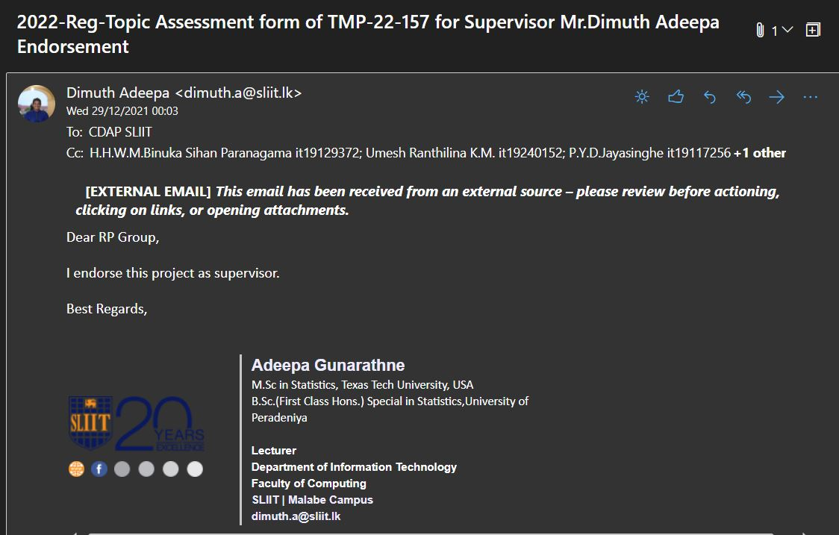

**Appendix 02**

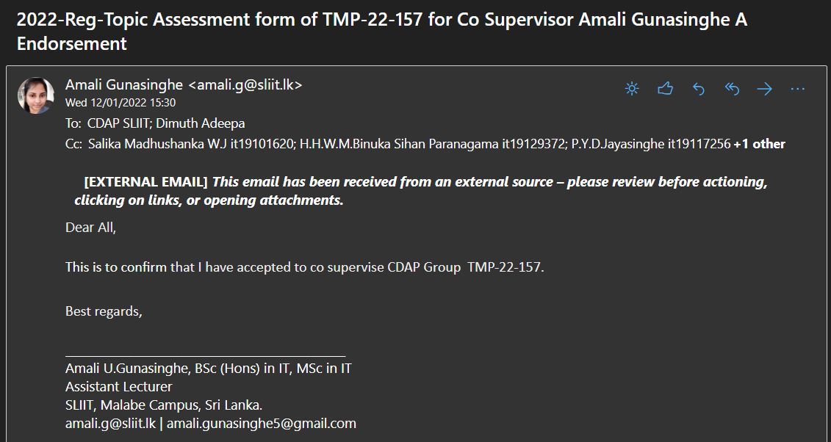

**Form approved by the panel**

